

MGT 233 | Marketing Research

Final Project: Energy Drink Consumption

Table of Contents

Executive Summary 3
I. Introduction 4
II. Literature Review 6
III. Research Questions 7
IV. Findings 9
V. Discussion 16
VI. Recommendations 19
Appendix 21
References 23

Executive Summary
This project investigates consumer behaviors and preferences for energy drink consumption, focusing on three primary research questions. Our findings show that brand reputation and online reviews significantly influence consumption. Stronger opinions on brand reputation correlated with lower consumption frequency, suggesting brand-conscious consumers are more selective. Reliance on online reviews correlated with higher consumption, highlighting peer reviews' critical role.
Willingness to purchase healthier alternatives strongly affects behavior. Participants not interested in healthier options consumed energy drinks more frequently, while individual health concerns, such as avoiding certain ingredients, did not significantly influence consumption.
Situational contexts, particularly work-related activities, strongly predicted energy drink consumption. "Work" had the strongest and most consistent influence, while driving and fitness had marginal effects. Collectively, these factors shaped consumption patterns.
Overall, energy drink consumption is complex and is influenced by brand perceptions, health considerations, and situational demands. Frequent consumers prioritize situational needs, particularly work-related contexts and peer influence, while health-conscious marketing resonates more with less frequent users.
Energy drink companies should focus on situation-specific marketing, targeting scenarios requiring mental alertness like work or study. Leveraging online reviews can engage frequent consumers while positioning products as healthier alternatives can attract health-conscious buyers.

Introduction
The American energy drink market has grown at a very high rate over the last decade, driven by consumer lifestyle changes, growing demand for functional drinks, and competitive advertising efforts by major brands. Energy drinks have transitioned from their early days as a niche beverage among athletes and bodybuilders to a mainstream drink among students, and corporate professionals. These beverages now reside as weapons of convenience in the war against fatigue, mental acuity, and physical ability as individuals work longer and longer hours either studying, working, or simply playing.
But as the market continues to expand, it is tainted by serious issues relating to consumer health and changing brand dynamics. The excessive caffeine, sugars, and potential side effects of the energy drink have raised eyebrows among consumers, medical professionals, and government regulatory bodies. As consumers become increasingly sensitive to their well-being, brands are caught in a continuously evolving playing field where they have to provide consumers with performance-based benefits as well as better and safer alternatives.
Parallelly, brand image is also the most important thing in shaping consumption habits. Brands spend a lot on endorsements, new packaging, and product segmentation to build customer loyalty. Influencer marketing, targeted digital promotion, and product innovation like sugar-free versions and natural ingredient formulations offer opportunities and challenges for companies to maintain market share and address changing consumer tastes.
Because this is a dynamic and competitive market situation, the greatest determinants of energy drink use, brand image, health, and situational use need to be determined so that firms can optimize product development, advertising, and industry positioning.
To confront this marketing challenge, the current research adopts a data-based approach, drawing on consumer insight in the study of the determinants of energy drink consumption. A systematic survey instrument was prepared to collect quantitative data on consumer attitudes, health problems, and situational usage occasions, including gaming, sports, and studying. The survey was conducted among a representative panel of energy drink consumers to identify differences in attitudes, likes, and behavior across different demographic segments.
The information collected was statistically computed in an attempt to identify significant patterns and connections. ANOVA examined if there are considerable differences between varying opinions and behavior groups concerning consumption behavior. Correlation matrices were utilized to examine the connection between brand perception, health concerns, and situational needs. In addition, linear regression tests were also employed to examine the explanatory functions of these predictors in explaining consumers' decisions and frequency of consumption of energy drinks. This study concludes with managerial implications to guide energy drink manufacturers, advertisers, and regulators on how best to enhance their strategies and better serve consumers.
Research Questions
- How do opinions about brands influence energy drink consumption?
- What is the impact of health concerns on consumer preferences and purchasing behavior?
- To what extent do situational needs, such as fitness, and studying, drive consumption patterns?

Literature Review
Title of the Paper | Journal | Major Findings
Energy Drink Consumption and Its Association with Health Outcomes in Young Adults | Journal of Public Health | Frequent energy drink consumption is linked to increased risks of cardiovascular issues, sleep disturbances, and anxiety, particularly among young adults.
Branding and Consumer Perceptions in the Energy Drink Market | Journal of Consumer Behavior | Strong branding, celebrity endorsements, and packaging significantly influence consumer choices, often outweighing health concerns.
Situational Consumption of Energy Drinks: A Study of Gamers, Students, and Athletes | Journal of Behavioral Nutrition | Different consumer groups (e.g., gamers, students, athletes) have unique consumption motivations, with gaming-related consumption being the highest.
Health Awareness and Energy Drink Consumption: A Paradox | Journal of Health Marketing | Despite growing health awareness, many consumers continue purchasing energy drinks due to taste, habit, and perceived energy benefits.
The Role of Sugar and Caffeine in Energy Drink Preferences | Journal of Food Science & Nutrition | Consumers are drawn to energy drinks primarily for their caffeine content, but there is increasing demand for sugar-free and natural ingredient alternatives.
Marketing Strategies and Consumer Loyalty in the Energy Drink Industry | Journal of Business and Marketing Research | Aggressive marketing campaigns and product innovation contribute to long-term brand loyalty, with younger consumers being the most responsive to digital advertising.
Regulatory Policies and Public Perception of Energy Drinks | International Journal of Policy Studies | Stricter labeling requirements and regulations have influenced consumer awareness, but actual purchasing behaviors remain largely unchanged.

Research Questions
This study is interested in how brand perception, health concerns, and situational needs influence the evolution of energy drink consumption in America. With these, this study seeks to uncover market drivers and provide stakeholder-ready results. To achieve this, the study provides answers to the following basic questions:
- How does energy drink consumption respond to the perception of a brand?
Brand perception is the fundamental driver of preference. Energy drink brand owners invest a lot of money in brand activities, including celebrity endorsements, pack creation, and social media advertising to impact consumer buying decisions. The role of brand image in the buying decision is of special interest to business owners as they wish to create a more powerful customer relationship and attract new consumers. Furthermore, with increasing brands in the market, brands need to differentiate on value characteristics such as sustainability, naturalness, or performance value. By studying the impact of brand perception on energy drink consumption, businesses can align their marketing efforts with evolving consumer demands.
- How much do health issues influence consumer attitudes and purchasing behavior?
Although energy drinks offer functional advantages of heightened alertness and improved performance, they have also been faulted for their caffeine and sugar content, which has negative health consequences such as cardiovascular complications, sleep problems, and addiction. With the increasing number of health-conscious consumers, there is a need to determine how perceptions of these risks affect consumer purchasing behavior. Do consumers make a special effort to look for low-sugar or natural ingredient versions? Are regulators' warnings and media coverage changing consumption patterns? Emphasis on these questions will allow manufacturers to develop healthier alternatives for their products and label products more openly.
- To what extent do situational needs, i.e., fitness, and learning, drive consumption patterns?
Energy drinks are typically marketed as cures for fatigue and performance enhancement in a specific context. Gamers, students, and athletes consume energy drinks for intense concentration, endurance, and energy stimulation. How much such situational determinants influence overall consumption is unclear. Do specific population segments depend more on energy drink consumption based on lifestyle requirements? Do situational needs dominate brand and health concerns in buying? The responses to these questions will allow businesses to more effectively target their target market and create product lines to suit different consumer segments.

Findings
We designed our survey to explore consumer behaviors and attitudes towards energy drink consumption. Participants first indicated whether they consumed energy drinks, and then further were asked about the frequency of consumption. Information about the context of consumption and motivations of consumption were collected. Our survey also examines the key factors that drive consumers to make decisions about energy drinks. Lastly our survey collected demographic information of our respondents.
To answer our research questions, we need to find relationships between those factors and energy drink consumption.
General information about our sample and survey responses is offered in detail in the appendices. Appendix A covers gender distribution, employment status, and energy drink consumption status. Appendix B provides age distribution and work habits. Appendix C presents descriptive statistics on participants' opinions regarding brand perception, health concerns, and situational contexts. Appendix D details energy drink consumption across different brands.
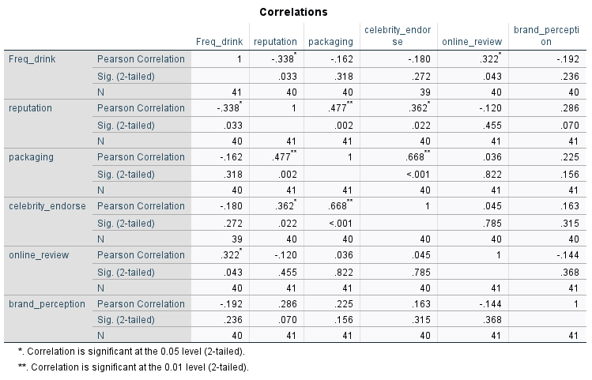
Research Question 1: How does brand perception influence energy drink consumption?
To understand how opinions on branding affect energy drink consumption, we collected and analyzed data through surveys to explore the relationship between the frequency of energy drink consumption and several dimensions of branding opinions: brand reputation, packaging, celebrity endorsements, online reviews, as well as overall brand image perception.
Our correlation analysis resulted in opinions of reputation and online reviews having a significant correlation with energy drink consumption, with the p-value being less than 0.05. The participants who value brand reputation highly tended to consume energy drinks less (r=-0.338), while the participants who value online reviews tended to consume more energy drinks (r=0.322). To interpret this result, we assume that consumers who value brand reputations might only consume selected brands and have very specific tastes in energy drinks, while consumers who value online reviews could be enthusiastic about energy drinks or regard peer opinions as important.
Other branding-related factors such as packages, celebrity endorsements, and overall brand image perception, did not show a significant correlation with the consumption frequency. This may indicate that those factors might be useful in the case of differentiating brands, however, not driving energy drink consumption frequencies.
One limitation of this correlation analysis is that the consumption frequencies have not been tied to specific brands but to participants’ perceptions of different factors for energy drinks in general. The result reflects this generality rather than how those factors would influence a specific brand.
Research Question 2: What is the impact of health concerns on consumer preferences and purchasing behavior?
To examine the influence that health concerns have on energy drink consumption, our survey explored attitudes towards specific ingredients, preferences for organic options, and willingness to purchase healthier alternatives. We conducted mean comparisons (ANOVA) for responses of health-related questions and consumption frequency.
Organic Options One-way ANOVA results:
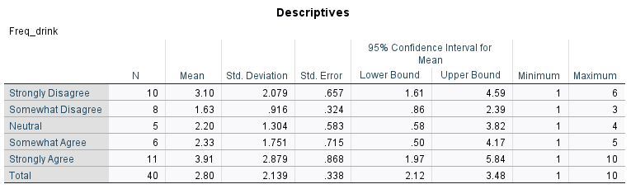
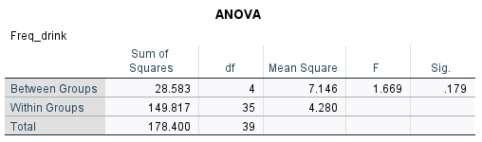
From the descriptive analysis, participants showed mathematical differences in their consumption frequencies based on their different levels of attitudes towards organic options. Specifically, in this case, participants who strongly agree with looking for organic options have the highest mean frequency, while participants who somewhat disagree with that sentiment showed the lowest mean consumption frequency. However, with a p-value that is greater than 0.05, the preferences for organic options alone did not significantly affect the frequency of consumption in our sample.
Ingredients Avoidance One-way ANOVA results:
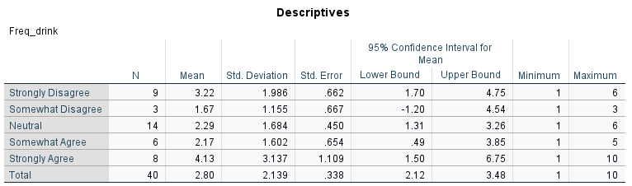
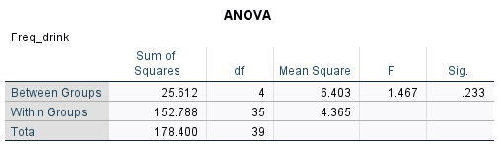
Descriptively, participants who strongly agreed with avoiding certain ingredients had the highest mean frequency while those who somewhat disagreed showed the lowest frequency. However, with a P value being 0.233, the results indicated no statistically significant difference between groups.
Willingness for Healthier Alternative One-way ANOVA results:
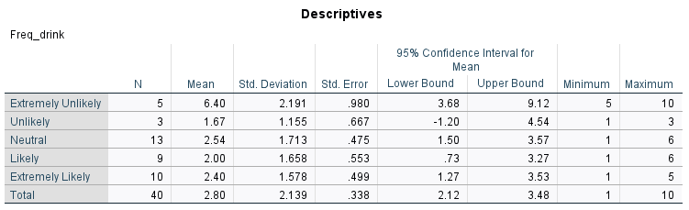
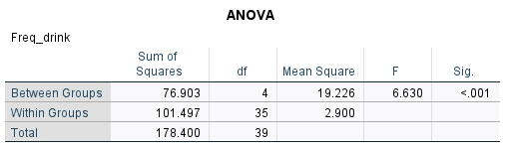
The result indicated that there exist statistically significant differences between the groups, with a p-value that is less than 0.001. Participants who were extremely unlikely to purchase healthier alternatives consumed energy drinks significantly more, with a mean of 6.4, compared to those who expressed neutral or positive willingness. The consumer group that seems to be extremely uninterested in or even against healthier options is a distinct group of frequent consumers, which implies that any healthier options promoted would mainly attract groups of less frequent consumers.
Research Question 3: To what extent do situational needs, such as fitness, and studying, drive consumption patterns?
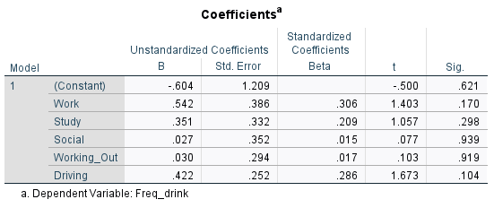
As none of the independent variables seems to be significant (p values are less than 0.05), we conducted a correlation analysis among the factors.
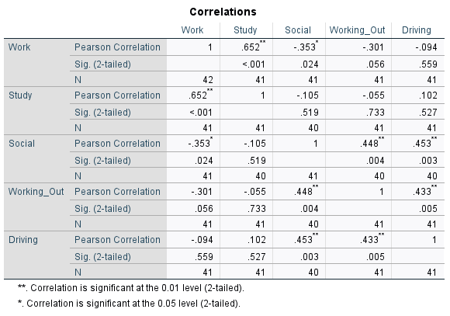
As shown in the correlation matrix, work and study, social and driving, and social and working out have shown a strong correlation, which means there exists multicollinearity in our regression model. Thus we decided to omit the factors of study and social.
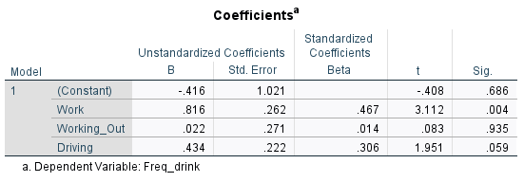
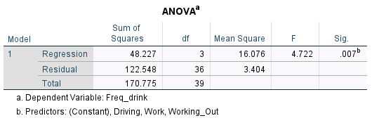
The updated multiple regression significantly predicted the consumption frequency, with a p-value of 0.007. Among the predictors, the “Work” context showed a significant and strong positive relationship with consumption frequency, while the other two factors showed a rather insignificant relationship. Given the strong correlation between work and study contexts, these findings suggest that situations involving productivity, such as working or studying, represent key situations driving energy drink consumption.

Discussion
What do your findings tell you about the problem you are addressing?
Based on the findings, one can achieve problems in the areas of energy drink consumption and marketing. From the data, we can observe that these are more than mere straightforward brand selection or health problems and expose problems related to consumer confidence, behavioral patterns, and product positioning. In general, beverage firms have relied on such methods of branding as celebrity endorsement, packaging, and brand reputation in shaping consumers. However, from the statistics, these may not hold for the strong purchase decision impact. Rather, consumers value peer opinion and web reviews while deciding what energy beverages to buy.
This shift puts the emphasis on a challenge. How do brands create loyalty and trust in this day and age where marketing messages alone are not enough? Investing money in advertising and endorsements alone may no longer be as effective as before. Instead, businesses have to engage consumers through digital media and word-of-mouth. The challenge is not anymore how to be noticed through branding but how to create a product and brand experience.
It has been possible to adopt healthier variants today for a variety of industries, but as per our study, consumers heavily relying on energy drinks do not embrace change in such options. They adhere to energy drinks for reasons of familiarity and taste and may provide an immediate and robust energy boost. In contrast, health-conscious buyers are avoiding energy drinks due to fear of processed content, excessive sugar content, and ill health.
This raises the challenge to brands in this way. If they continue to produce in conventional ways, they might be shutting out prospective new consumers, but if they focus too much on healthier alternatives, they are unable to purchase their most faithful buyers who use the powerful impacts of the product. This cross-purpose of consumer preference is a major challenge because energy drink brands must navigate the conflicting forces of those who seek effectiveness and those who seek more healthful choices without losing market share. Energy drinks have traditionally been marketed through partnerships with sports, nightlife, and action. Our analysis shows, however, that those messages aren't the main reason people use them. As per the data, energy drinks are consumed primarily for productivity to keep them awake in the workplace or study environment.
Our research shows a disconnection between advertising of energy drinks and consumer consumption. Companies market energy and thrill, but consumers consume energy drinks primarily for focus, productivity, and endurance in work and school settings.
This misalignment creates two challenges: brands must adjust their communications to emphasize focus, stamina, and mental clarity, rather than adrenaline-driven lifestyles. They must also get in front of the appropriate consumers, outside of entertainment and sports into academic, corporate, and professional settings. The category's past branding is no longer congruent with consumer lifestyles, and to stay competitive, companies must reposition energy drinks as productivity aids, rather than simply as symbols of high-energy lifestyles.
Explain how marketing tactics/principles/strategies are employed in solving the issue
To counter these issues, energy drink manufacturers must embrace the consumer-centric perspective. This does so by helping to establish credibility, improve convenience, and answer the needs of different consumer bases.
- Building Trust Through Engagement
As the effectiveness of traditional advertising decreases, people increasingly depend on friend opinions and web ratings. Brands must connect with consumers by using digital media. Consumer experiences make a brand authentic, and influencer collaboration helps build trust. As an example, reward programs for endorsers can also cause people to extend their reputation. Brands must also start conversations where customers can share their opinions, making the brand human and building loyalty.
- Raising Distribution in Productivity Areas
Since people only use energy drinks to stay alert and energized throughout work or studying, businesses must distribute them conveniently in the right places.
Putting vending machines within libraries, universities, and coworking offices can get them conveniently within reach. Associating with businesses can make energy drinks a daily office staple. Putting them on food delivery sites can also turn them into a late-night work or study break choice. Positioning energy drinks where people most need them is a way that brands can improve convenience and aid in daily productivity.
- Meeting Traditional and Health-Focused Consumers
Traditional energy drinks are the choice of some of the most devoted customers, yet health-focused consumers avoid them due to ingredient concerns.
To serve additional consumers, brands can offer healthier options without reformulating their current products. Regular energy drinks can remain at typical stores, and healthier versions can be offered in speciality stores. Using separate branding for both ranges can appeal to additional consumers without alienating current consumers. Through the creation of distinct product lines, brands can expand their customer base without alienating their current ones.

Recommendations
Our conclusions in research translate into several recommendations that energy drink producers can undertake to enhance marketing and align their strategies with customer needs.
For Marketers:
- Create Brand Trust Through Transparency
Reputation of a brand has a significant contribution to make towards consumer choice. Companies have to give due importance to honest marketing and emphasizing their product quality, participating in corporate social responsibility programs to create improved consumer trust. Building a good brand image leads to loyal customers as well as long-term business success.
- Maximize the Impact of Online Reviews
They generally look to internet reviews in order to make their selection of energy drinks to buy. Companies need to motivate their satisfied customers to leave positive reviews while having a courteous interaction with all feedback forms. Effective online presence management can have an impact on customer perceptions and boost product sales figures.
For Policy Makers:
- Strengthen Labeling and Marketing Regulations
Imposing more stringent product advertising and labeling regulations will enable consumers to make better purchasing decisions. Clearly labelling information on ingredients, caffeine levels, and health risks helps consumers steer clear of deception and promotes moderate consumption.
- Increase Public Sensitivity on Consumption Risks
A large percentage of customers particularly among the younger populations still lack knowledge of the possible hazards involved in excessive consumption of energy drinks. Public health programs inform individuals of safe levels of consumption while cautioning against potential side effects in a bid to make consumption more prudent.
For Future Research:
- Investigate Long-Term Health Consequences
Recent studies aim at short-term impacts but require additional research to determine the long-term effects of energy drink intake. Research on the influence of such drinks on cardiovascular health concerning mental health and lifestyle habits provides important data for consumers and policy makers.
- Examine Consumer Interest in Healthier Alternatives
Customers more and more are looking for cleaner, natural energy drink alternatives. Future studies need to measure not just consumer satisfaction with these newer energy drink alternatives, but the actual purchasing effect versus traditional favorites.

Appendix
Appendix A
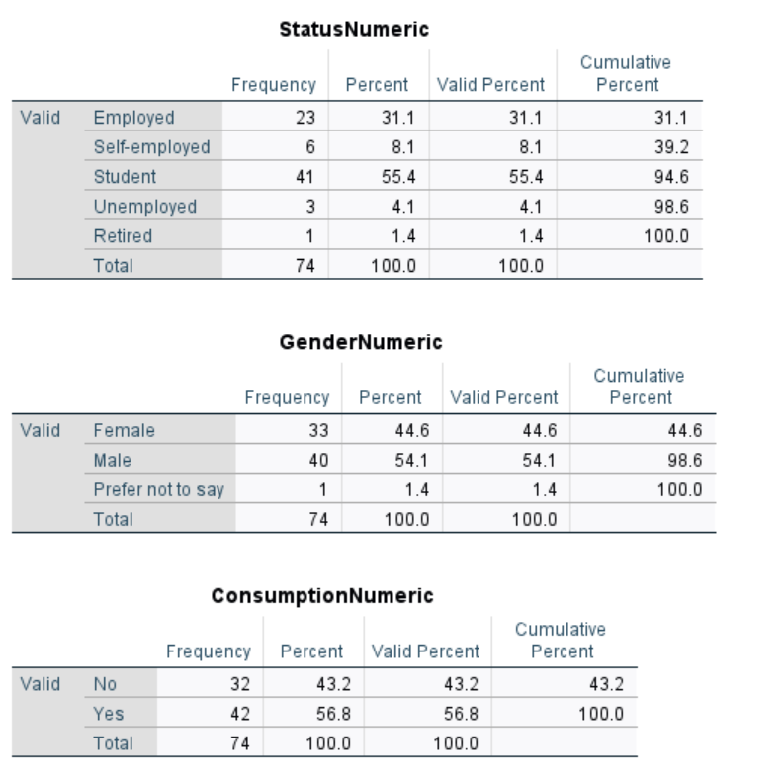
Appendix B
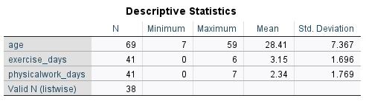

Appendix C
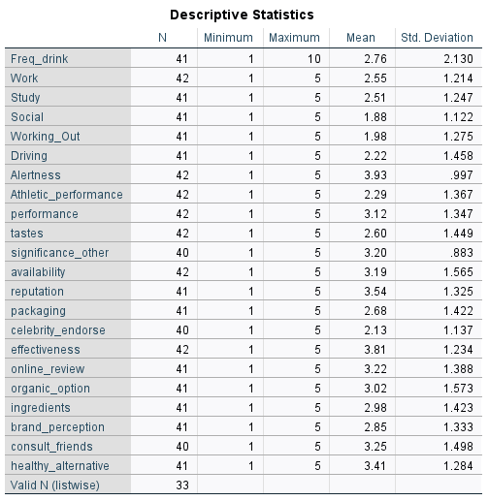
Appendix D
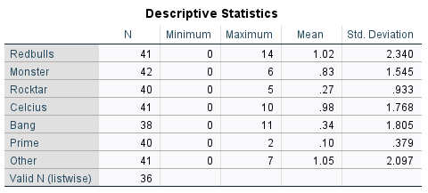

References
Seifert, S. M., Schaechter, J. L., Hershorin, E. R., & Lipshultz, S. E. (2011). Health effects of energy drinks on children, adolescents, and young adults. Pediatrics, 127(3), 511-528. https://doi.org/10.1542/peds.2009-3592
Aslam, A. (2023). What are the drivers of brand perception and preferences in the energy drink industry? Nova School of Business and Economics Working Paper Series.
Hammond, D., Reid, J. L., & Zukowski, S. (2018). Exposure and perceptions of marketing for caffeinated energy drinks among young Canadians. Public Health Nutrition, 21(3), 535-542. https://doi.org/10.1017/S1368980017003220
Costa, B. M., Hayley, A., & Miller, P. (2014). Young adolescents' perceptions, patterns, and contexts of energy drink use: A focus group study. Appetite, 80, 183-189. https://doi.org/10.1016/j.appet.2014.05.004
Heckman, M. A., Sherry, K., & Gonzalez de Mejia, E. (2010). Energy drinks: An assessment of their market size, consumer demographics, ingredient profile, functionality, and regulations in the United States. Comprehensive Reviews in Food Science and Food Safety, 9(3), 303-317. https://doi.org/10.1111/j.1541-4337.2010.00111.x
Pettigrew, S., Bi, P., & Daube, M. (2015). Energy drinks: Health risks and toxicity. Medical Journal of Australia, 203(1), 46-50. https://doi.org/10.5694/mja15.00094
Breda, J. J., Whiting, S. H., Encarnação, R., Norberg, S., Jones, R., Reinap, M., & Jewell, J. (2014). Energy drink consumption in Europe: A review of the risks, adverse health effects, and policy options to respond. Frontiers in Public Health, 2, 134. https://doi.org/10.3389/fpubh.2014.00134

